Quantum Born Machines (QBM-Born) and Probabilistic Circuit-Based Models

1. Problem
Probabilistic generative modeling aims to learn an unknown probability distribution from data and generate new samples from it. Classical models such as Boltzmann machines and autoregressive models approximate these distributions but can struggle with high-dimensional correlations.
Quantum Born Machines (QBMs) address this problem by directly using the Born rule of quantum mechanics: probabilities are obtained from the squared amplitudes of a quantum state prepared by a parameterized quantum circuit.

2. Intuition
The core idea of a Quantum Born Machine is simple:
- A parameterized quantum circuit prepares a quantum state (|())
- Measuring the circuit produces bitstrings
- The measurement probabilities define a learned probability distribution
Unlike Boltzmann Machines, QBMs do not require an energy function or thermal sampling—the quantum state itself represents the model distribution.

3. Model / Circuit Structure
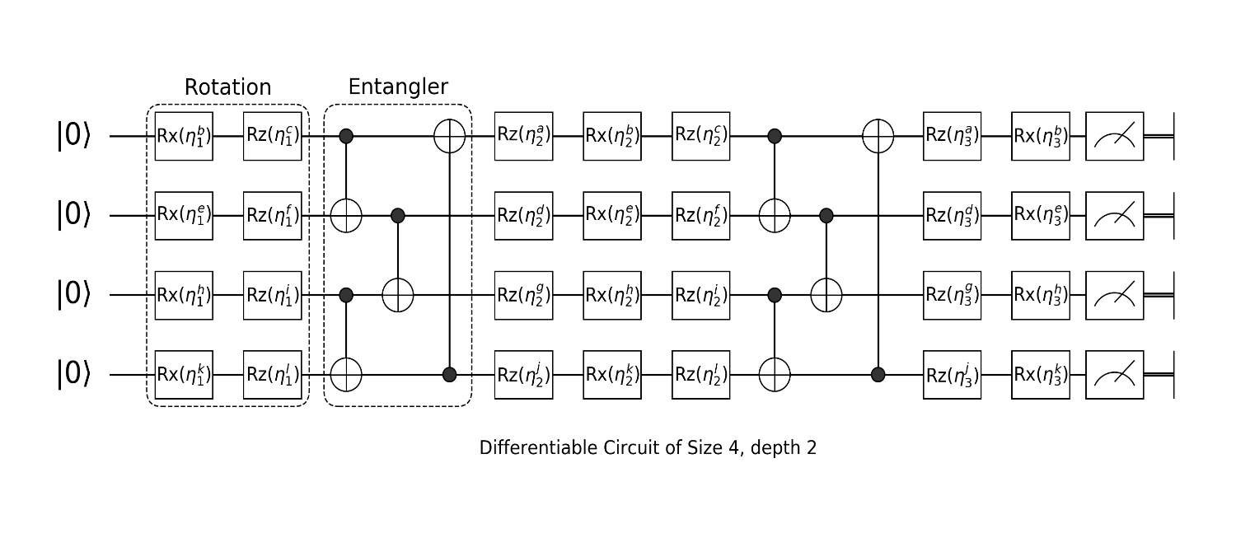
A typical Quantum Born Machine consists of:
- Initialization
All qubits start in (|0).
- Parameterized Quantum Circuit (Ansatz)
Layers of single-qubit rotations and entangling gates.
- Measurement
Measuring all qubits yields samples from the learned distribution.
High-level flow:
[ |0 |() x p_(x) ]

4. Simple Math Involved
- State preparation: [ |()= U()|0 ]
- Born rule: [ p_(x) = |x | () |^2 ]
- Training objective: [ D(p{} || p_) ]
where (D) is a divergence measure such as KL divergence.

5. Python Code (Quantum Born Machine – Qiskit)
import numpy as np
from qiskit import QuantumCircuit
from qiskit.circuit.library import RealAmplitudes
from qiskit.primitives import Sampler
num_qubits = 3
ansatz = RealAmplitudes(num_qubits, reps=2)
qbm = QuantumCircuit(num_qubits)
qbm.compose(ansatz, inplace=True)
qbm.measure_all()
sampler = Sampler()
job = sampler.run(qbm, shots=2048)
result = job.result()
distribution = result.quasi_dists[0]
print("Learned probability distribution:")
for bitstring, prob in distribution.items():
print(bitstring, prob)

6. Where the Algorithm Is Useful
- Generative modeling
- Learning probability distributions
- Benchmarking quantum sampling
- Quantum-enhanced unsupervised learning

7. Limitations
- Training can be slow
- Barren plateaus may occur
- No guaranteed quantum advantage
- Limited scalability on NISQ hardware

8. Comparison with Classical Probabilistic Models
- Model: Classical models define explicit probabilities; QBMs use quantum amplitudes
- Sampling: Classical MCMC vs. quantum measurement
- Energy function: Required classically, not needed in QBMs
- Maturity: Classical models are mature; QBMs are experimental

9. One-Sentence Summary
Quantum Born Machines are generative models that learn probability distributions directly from quantum measurement outcomes using the Born rule.

